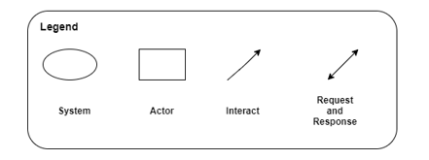

Feedback

Request

User

Feedback

Request

Changed Password

Login/Logout

Device